Work Log

Background
Arduino
Uno or Nano
Sensors
Electrosmith
Daisy
Seed

Audio Out
Data Logging to SD card
Code interprets sensor data and converts to EDS- readable and loggable form
Data interpreted by Plug Data Code

251509
- Arduino nano every (ANE) and arduino uno rev 4 (AUR4) successfully reading digital temperature and humidity reading from DHT11 sensor
- And successfully reading a light dependent resistor (LDR)

250918
- Electrosmith Daisy Seed (EDS) flashed with blink patch via web programmer
- Daisy flashed with patch made in plug data (PD) via PD compiler
  - Because both of these patches only used the EDS’s onboard Digital Audio Converter (DAC) and does not utilize input from GPIO pins there is no need for a custom JSON
  - 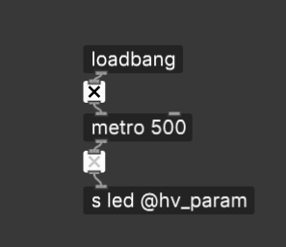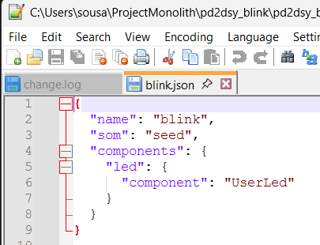
- Electrosmith daisy flashed with new patch built in PD
  - 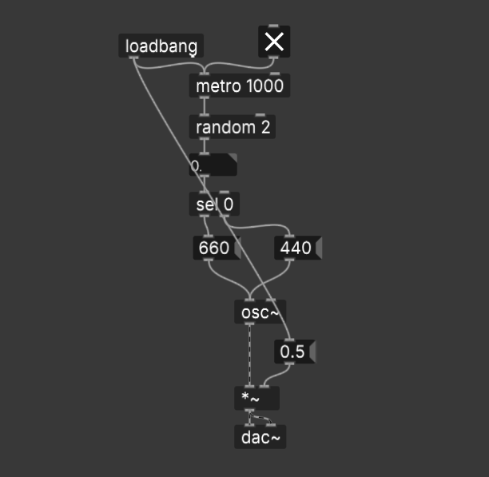
- Successfully played “music” out of the electrosmith based on above patch.
- Next Goal : get data from arduino into daisy
  - Write an arduino program which outputs numbers which follow sine wave pattern
  - Write a daisy program which generates frequencies based on oscillations.

250920

- Successfully flashed the AUR4 with code which reads a Light dependent resistor and changes the brightness of a bulb in response.
- Semi-successfully flashed the EDS board with a custom patch and a custom JSON.
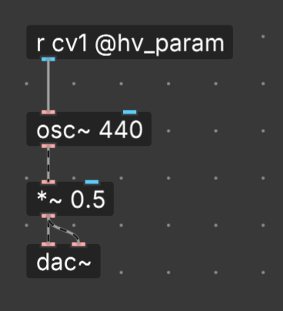
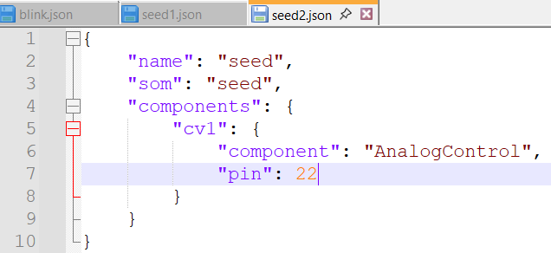

- So far, although the patch and JSON refer to a cv1 parameter I have not had any success controlling it from AUR4 output.
  - This is almost certain due to:
    - some failure on the part of the patch or the JSON to route the voltage coming in properly
      - This could be explained by using terminology that the board is not designed to understand -: cv1. However cv1 is used in example JSONs online CONFIRM THIS.
      - LATER EDIT : The name I was using was “pin 22” thinking that I was referencing the pin which comes 22nd when physically counting the pins starting on one side and moving in order from one to another. However, this is not the way pins are referenced in the arduino code. By listing the relevant pin as “22”, I was actually pointing to pin A7/D22 which is actually the 29th pin numerically. Communication was ineffective due to this mismatch.
    - The patch has a default value of 440 - this could be overriding input data
    - The patch could not be “banging” the right inputs or messages
    - Bad wiring
- To troubleshoot I have stripped down the system to its essential components to test the functionality of each component:
  - GPIO input testing: After much frustration I have managed to control the pitch of an oscillator based on a potentiometer being fed a 3.3V charge from the daisy itself.
    - I wired the 3.3V output to a potentiometer and then back into another GPIO designated as an input. I routed the value of this pin to the pitch of a simple oscillator (after some mathematical manipulation to bring it into a more reasonable frequency and range)
  - I then improved on this by swapping the potentiometer out for a voltage originating from the Arduino thus proof of concept has been achieved.
  - It seems the issue was the disparity between the numerical order of the pins and the way pins are referenced in the software.
  - In any case the troubleshooting phase of reducing the system to the fewest components and building from there worked very well.
  - My final Arduino code, patch, and JSON looked like this:
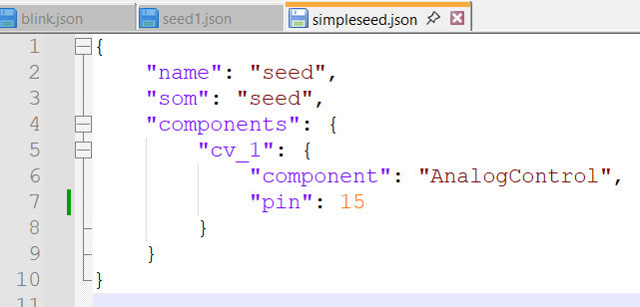
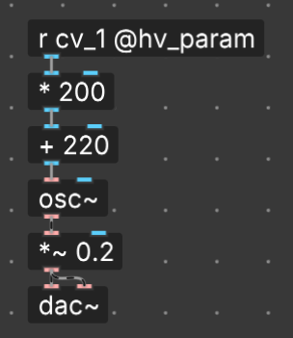

250921

Music idea inspired by Tristan Perich
- Something that feels like a plant growing toward the light. Searching iterating, improving, exploring, driven by some ever-changing abiotic factor (sunlight intensity)
  - A scale that grows and changes based on parameters.
    - A C scale with a base of 12 notes at STP
      - The window of notes shifts upward in brighter light
      - The tempo increases in higher temperatures
      - The scale itself changes on humidity
  - Proof of concept
    - C scale with variable notes based on light
      - More light = higher register

250925

Music ideas inspired by windchimes and John Coltrane’s Giant Steps
- Giant Steps is famous for rapidly switching keys in a way that is still harmonious. John Coltrane was pushing the limits of jazz harmony and switching keys with nearly every note he played. Despite maintaining the classic 2-5-1 jazz progression.
- IDEA: Piece that only played three notes but modulated aspects of those notes based on environmental parameters.
  - Tempo - temperature
  - Key - Humidity
  - Timbre - Lux

Music idea inspired by JW Buckley
- Any field recording can be “tonalized” via EQ manipulation
  - Grab any ambient semi-consistent sound (e.g wind, rain, river, etc.)
  - In a DAW manipulate the volume of particular frequencies to match the harmonic signature of your desired note and timbre
    - For a simple concert A - amplify 440Hz, 880, 1320, 1760, etc.
  - On playback there will be an audible note to the sound.
- IDEA: Field recordings are taken by Monolith, acoustically modified in this way, and then played-back as tones in another patch (perhaps a simplistic wind chime like above).

Music concept inspired by the geography of food
- It is a common statement that foods tend to follow latitude - available ingredients, appeal of hot vs cold, spicy vs sweet etc.
- IDEA: connect environmental parameters to common conditions in particular geographic locales.
- Examples:
  - High humidity, light, and temp = tropics and tropic scales.
  - High humidity, low light, low temp = snowy and wet rainy climates and scales
  - Low humidity, high temp - deserts cultures and and relevant scales

251221

3-axis Magnetometer as a theramin control
Button = envelope trigger (like hitting a piano key)
3-D rotation of an object is the Pitch, Timbre, and … volume?

